Geophysical Research Letters
Supporting Information for
Geophysical imaging of shallow degassing in a Yellowstone hydrothermal system
S. Pasquet^{1, 2}, W. S. Holbrook^{1, 2}, B. J. Carr^{1, 2}, K. W. W. Sims¹
¹University of Wyoming, Department of Geology and Geophysics, Laramie, Wyoming, USA.
²University of Wyoming, Wyoming Center for Environmental Hydrology and Geophysics, Laramie, Wyoming, USA.

Contents of this file

Text S1
Figures S1 to S11
Table S1
Introduction
This supporting information contains a detailed description of geophysical data processing and rock physics modeling.

Text S1.

MATERIAL AND METHODS

Electrical resistivity tomography

We performed electrical resistivity tomography (ERT) along this transect using an 8-channel AGI SuperSting system with a mixed array composed of an extended dipole-dipole and strong gradient arrays. The fundamental reason to combine arrays is to take advantage of the strengths of each array and improve the final inversion. On the one hand, the extended dipole-dipole provides good lateral sensitivity, a lot of redundant data but poorer data quality with depth. On the other hand, the strong gradient provides less data, less lateral resolution, but better quality at depth and vertically resolved data to compensate the weaknesses of the extended dipole-dipole. Apparent electrical resistivity data were filtered to remove data with low injected current, low voltage and high repeatability error. We then estimated measurement error with reciprocal error analysis [Slater et al., 2000; Koestel et al., 2008; Heenan et al., 2014]. The error was calculated for each measurement presenting a reciprocal using the following equation:

 | $$ε_{R}=R_{n}-R_{r},$$ | (S1)

where R_{n} is the normal measurement of the resistance and R_{r} is the reciprocal measurement. After removing data points with reciprocal error higher than 10%, we represented errors calculated with Equation S1 as a function of resistance in a log-log scale and fitted a linear trend through the data. The fitting equation was then used to estimate the error for each measurement as a function of the measured resistance (Figure S1). Apparent electrical resistivity data were eventually inverted for true electrical resistivity structure using the R2 software package (available at http://www.es.lancs.ac.uk/people/amb/Freeware/R2/R2.htm). R2 uses a finite element forward model solution and an Occam's regularized inversion approach [Binley and Kemna, 2005]. We used a homogeneous starting model with a resistivity of 10 Ohm.m and a total of 6 iterations to converge and obtain a final model with a misfit below 1 (Figure S2a).

We finally estimated the depth of investigation (DOI) using the DOI index [Oldenburg and Li, 1999] and the sensitivity matrix (Figure S2b) provided by R2. The DOI index (Figure S2c) was calculated by comparing models obtained after two inversions regularized to different homogeneous starting models and is defined as:

 | $$DOI\left(x,z\right)=\frac{m_{1}\left(x,z\right)-m_{2}(x,z) }{m_{1r}-m_{2r}},$$ | (S2)

where m_{1r} and m_{2r} are the values used to define the resistivity of the homogeneous starting model of each inversion, and m₁(x,z) and m₂(x,z) are the final models from each inversion. We used starting models with m_{1r} = 1 Ohm.m and m_{2r} = 10 Ohm.m. The investigation depth was then defined with the combination of the DOI index (with a threshold of 0.2) and the logarithm of the sensitivity (with a threshold of -0.75), using the maximum investigation depth estimated with both criteria at each position along the line. We finally compared observed and calculated apparent electrical resistivity for each quadripole (Figure S3a and b), and computed their residuals (Figure S3c and d) to check the quality of the inversion. The final model has a RMS of 14 Ohm.m, with 94% of the samples with residuals less than 28 Ohm.m.

Seismic refraction tomography

We acquired seismic data using eight 24-channel Geometrics Geode systems and 10 Hz vertical-component geophones. We manually picked travel times on each seismogram with a signal-to-noise ratio high enough to confidently identify the first arrivals (Figure S4). We then inverted the travel-time observations for subsurface V_{P} structure using a MATLAB travel-time tomography code [St. Clair, 2015]. The inversion is parameterized as a sheared mesh of constant velocity parallelograms. The horizontal dimensions of each cell are fixed, while the vertical dimension increases linearly with depth. Rays are traced through the mesh using a shortest path algorithm [Dijkstra, 1959; Moser, 1991] and updates are found by solving a regularized, linear inverse problem. The program starts with an initial model consisting of a velocity field that increases linearly with depth, and then finds an appropriately smooth update to the model that reduces the difference between predicted and observed travel times.

To quantify uncertainty, model sensitivity and investigation depth, we used a Monte Carlo approach by repeating the inversions for a range of starting models with different surface velocities and velocity gradients [St. Clair et al., 2015] (Figure S5a). All the models presenting a satisfactory fit to the data (Figure S5b) were used to build an average final model (Figure S5c), with a depth of investigation estimated from the standard deviation of all selected models (Figure S5d). We used a threshold of 200 m/s on the standard deviation to determine the investigation depth and limit the extent of the V_{P} model. We finally compared observed and calculated traveltimes for each source-receiver pair (Figure S6a, b and d), and computed their residuals (Figure S6c and e) to check the quality of the inversion. The final model has a RMS of 2.96 ms, with 80% of the samples with residuals less than 3.8 ms.

Surface-wave dispersion inversion and profiling

The seismic data were also processed to perform surface-wave dispersion inversion and profiling [Pasquet and Bodet, 2016] using the SWIP software package (available at https://github.com/SWIPdev/SWIP/releases). SWIP uses windowing and stacking techniques [O’Neill et al., 2003; Neducza, 2007] to take advantage of redundant seismic data and retrieve a 2D model of V_{S} from a succession of 1D inversions. We used a 26-m moving window to extract seismic data subsets along the line and narrow-down the lateral extent of dispersion measurements. Subsets were extracted from shots located between 2 and 10 m from the first trace of each 26-m window. From each of these subsets, we computed dispersion images in the frequency-phase velocity domain using a slant stack in the frequency domain [Mokhtar et al., 1988]. Dispersion images computed from subsets centered at the same position (Xmid) were then stacked together in order to increase signal-to-noise ratio and help for mode identification (Figure S7). The window size was selected after trial and error tests so as to consider a 1D medium below the data subset; a shift between windows of 2 m was selected to obtain smooth lateral variations between adjacent windows. On each dispersion image, the coherent maxima associated with the different surface-wave propagation modes were identified, picked and extracted with a standard error in phase velocity depending on the image resolution as proposed by O’Neill [2003].

Assuming a 1D layered medium, we performed 1D Monte Carlo inversions of dispersion curves picked at each Xmid to obtain a set of consecutive 1D V_{S} models. Theoretical dispersion curves were computed from the elastic parameters using the Thomson-Haskell matrix propagator technique [Thomson, 1950; Haskell, 1953] as implemented by Dunkin [1965]. The inversion was completed with the neighborhood algorithm (NA) developed by Sambridge [1999] and implemented for near-surface applications by Wathelet et al. [2004] within the open software package Geopsy. The NA performs a stochastic search of a pre-defined parameter space (namely V_{P}, V_{S}, density and thickness of each layer) using the misfit function defined in Wathelet et al. [2004]. Based on a priori geological knowledge and P-wave refraction results, we used a parameterization with a stack of ten layers overlaying a half-space to look for smooth non-linear velocity gradients. The thickness of each layer was allowed to range from 0.5 m to 2.5 m. The valid parameter range for sampling velocity models was 10 m/s–1500 m/s for V_{S}, with velocities constrained to only increase with depth, while V_{P} was automatically parameterized from P-wave tomography results. For each 1D inversion, models matching the observed data within the error bars were selected to build a misfit-weighted final model (Figure S8).

We then estimated the investigation depth from the standard deviation of all selected models. We used a threshold of 150 m/s on the standard deviation to determine the investigation depth and limit the extent of the V_{S} model (Figure S9b). Finally, each 1D V_{S} model was represented at its corresponding extraction position to create a 2D V_{S} section (Figure S9a). We eventually compared observed and calculated phase velocity for each window position (Figure S10a, b, e and f), and computed their residuals (Figure S10c, d, g and h) to check the quality of the inversion. The final model has a RMS of 10.6 m/s (Figure S10i), with 94% of the samples with residuals less than 20 m/s.

Rock physics modeling

In order to provide quantitative estimates of porosity and saturation along the profile, we used a rock physics model relying on the Hertz–Mindlin contact theory [Mindlin, 1949], as formulated by Helgerud et al. [1999] and Helgerud [2001]. We were able to estimate porosity and saturation distributions in the subsurface from our seismic velocity models by predicting the P- and S-wave velocities of a mineral aggregate over a range of possible porosities and saturations, and finding the porosities and saturations that best match the observed velocities.

With this approach, we consider the medium as an aggregate of randomly packed spherical grains and express their bulk elastic properties (i.e. bulk and shear modulus) as functions of the elastic properties of constituent minerals, porosity, saturation, and a critical porosity(ϕ_{c}). This critical porosity defines the limit at which the medium changes from a suspension to a grain-supported material. As recommended by Nur et al. [1998], we used a critical porosity of 36%. We then applied the Hertz–Mindlin theory and calculated the effective bulk modulus (K_{HM}) of the dry rock frame at ϕ_{c}:

 | $$K_{HM}={\left[\frac{n^{2}{\left(1-ϕ_{c}\right)}^{2}{G_{s}}^{2}}{18π^{2}{\left(1-ν_{s}\right)}^{2}}P_{eff}\right]}^{\frac{1}{3}},$$ | (S3)

where P_{eff} is the effective pressure; n is the average number of contacts per grain in the sphere pack (we used n = 5, according to Bachrach et al. [2000]); ν_{s} and G_{s} are the Poisson’s ratio and the shear modulus of the solid phase, respectively. Since the traditional Hertz-Mindlin formulation often overestimates shear-wave velocities in unconsolidated media [Bachrach and Avseth, 2008], we used the approach proposed by Mavko et al., [2003] to calculate the shear modulus (G_{HM}). This approach allows a fraction f of the grain contacts to be frictionless (we used f = 0.5, following Johansen et al. [2013]), the rest having perfect adhesion:

 | $$G_{HM}=\frac{2+3f-(1+3f)ν_{s}}{5\left(2-ν_{s}\right)}{\left[\frac{3n^{2}{\left(1-ϕ_{c}\right)}^{2}{G_{s}}^{2}}{2π^{2}{\left(1-ν_{s}\right)}^{2}}P_{eff}\right]}^{\frac{1}{3}}.$$ | (S4)

For fully saturated media, we calculated P_{eff} as:

 | $$P_{eff}=\left(ρ_{b}-ρ_{w}\right)gD,$$ | (S5)

where ρ_{b} is the bulk density of the medium; ρ_{w} is the density of water; g is the acceleration due to gravity; and D is depth below ground level. For partially saturated media, P_{eff} was calculated as:

 | $$P_{eff}=ρ_{b}gD.$$ | (S6)

Poisson’s ratio ν_{s} was calculated from G_{s} and K_{s} (the solid phase bulk modulus) using:

 | $$ν_{s}=\frac{1}{2}\frac{3K_{s}-2G_{s}}{3K_{s}+G_{s}}.$$ | (S7)

The effective moduli of the solid phase were calculated from those of the individual mineral constituents [Hill, 1952] such as:

 | $$\left(K_{s},G_{s}\right)= \frac{1}{2}\left[\sum_{i=1}^{m}{f_{i}\left(K_{i},G_{i}\right)+{\left(\sum_{i=1}^{m}{\frac{f_{i}}{\left(K_{i},G_{i}\right)}}\right)}^{-1}}\right],$$ | (S8)

where m is the number of mineral constituents, f_{i} is the volumetric fraction of the i-th constituent of the solid phase, and K_{i} and G_{i} are the bulk and shear moduli of the i-th constituent, respectively. The density of the solid phase was then calculated following:

 | $$ρ_{s}=\sum_{i=1}^{n}{f_{i}ρ_{i}}.$$ | (S9)

For porosity ϕ less than ϕ_{c}, the bulk (K_{dry}) and shear (G_{dry}) moduli of the dry frame were calculated with the modified lower Hashin-Shtrikman (H-S) bound [Dvorkin and Nur, 1996]:

 | $$K_{dry}={\left[\frac{\frac{ϕ}{ϕ_{c}}}{K_{HM}+\frac{4}{3}G_{HM}}+\frac{1-\frac{ϕ}{ϕ_{c}}}{K_{s}+\frac{4}{3}G_{HM}}\right]}^{-1}-\frac{4}{3}G_{HM},$$ | (S10)

 | $$G_{dry}={\left[\frac{\frac{ϕ}{ϕ_{c}}}{G_{HM+Z}}+\frac{1-\frac{ϕ}{ϕ_{c}}}{G_{s}+Z}\right]}^{-1}-Z.$$ | (S11)

For porosity higher than ϕ_{c}, K_{dry} and G_{dry} were calculated with the modified upper H-S bound:

 | $$K_{dry}={\left[\frac{\frac{1-ϕ}{{1-ϕ}_{c}}}{K_{HM}+\frac{4}{3}G_{HM}}+\frac{\frac{ϕ-ϕ_{c}}{{1-ϕ}_{c}}}{\frac{4}{3}G_{HM}}\right]}^{-1}-\frac{4}{3}G_{HM,}$$ | (S12)

 | $$G_{dry}={\left[\frac{\frac{1-ϕ}{{1-ϕ}_{c}}}{G_{HM+Z}}+\frac{\frac{ϕ-ϕ_{c}}{{1-ϕ}_{c}}}{Z}\right]}^{-1}-Z.$$ | (S13)

In both cases, Z was defined as:

 | $$Z=\frac{G_{HM}}{6}\left(\frac{{9K}_{HM}+8G_{HM}}{K_{HM}+2G_{HM}}\right).$$ | (S14)

We then used the patchy saturation model [Dvorkin and Nur, 1998] to estimate the effective bulk modulus in a partially saturated medium:

 | $$K_{sat}={\left[\frac{S_{w}}{K_{{sat}^{wat}}+\frac{4}{3}G_{dry}}+\frac{1-S_{w}}{K_{{sat}^{gas}}+\frac{4}{3}G_{dry}}\right]}^{-1}-\frac{4}{3}G_{dry},$$ | (S15)

where S_{w} is the water saturation. $K_{{sat}^{wat}}$ and $K_{{sat}^{gas}}$ were calculated from Gassmann’s equations [Gassmann, 1951] and represent the bulk moduli of the sediment fully saturated with water and gas, respectively:

 | $$K_{{sat}^{wat}}=K_{s}\frac{ϕK_{dry}-\frac{\left(1-ϕ\right){K_{wat}K}_{dry}}{K_{s}}+K_{wat}}{\left(1-ϕ\right)K_{wat}+ϕK_{s}-\frac{K_{wat}K_{dry}}{K_{s}}},$$ | (S16)

 | $$K_{{sat}^{gas}}=K_{s}\frac{ϕK_{dry}-\frac{\left(1-ϕ\right){K_{gas}K}_{dry}}{K_{s}}+K_{gas}}{\left(1-ϕ\right)K_{gas}+ϕK_{s}-\frac{K_{gas}K_{dry}}{K_{s}}}.$$ | (S17)

Furthermore, the effective shear modulus in a partially saturated medium was calculated with:

 | $$G_{sat}=G_{dry}.$$ | (S18)

Finally, the bulk density ρ_{b} of the medium was defined as:

 | $$ρ_{b}=ϕ\left(S_{w}ρ_{w}+\left(1-S_{w}\right)ρ_{g}\right)+\left(1-ϕ\right)ρ_{s},$$ | (S19)

where ρ_{w}, ρ_{g} and ρ_{s} are the densities of the water, gas and solid phases, respectively. Once the bulk elastic moduli and density were known, the elastic wave velocities were calculated from:

 | $$V_{P}=\sqrt{\frac{K_{sat}+\frac{4}{3}G_{sat}}{ρ_{b}}},$$ | (S20)

 | $$V_{S}=\sqrt{\frac{G_{sat}}{ρ_{b}}}.$$ | (S21)

Using equation S20 and S21, we calculated V_{P} and V_{S} for each point of our model with a grid search on porosities and saturations. We then looked for the porosities and saturations best fitting both velocities, using a mixture of 40% quartz, 10% feldspar and 50% clay with typical elastic parameters [Mavko et al., 2003] (Table S1). Porosity and saturation ranged from 0 to 0.6 and from 0 to 1, respectively, both with a step of 0.025. We finally compared observed and calculated velocities for each point of the model (Figure S11a, b, e and f), and computed their residuals (Figure S11c, d, g and h) to check the quality of the inversions. The final V_{P} model has a RMS of 9 m/s, with 94% of the samples with residuals less than 17 m/s. The final V_{S} model has a RMS of 10 m/s, with 94% of the samples with residuals less than 20 m/s.

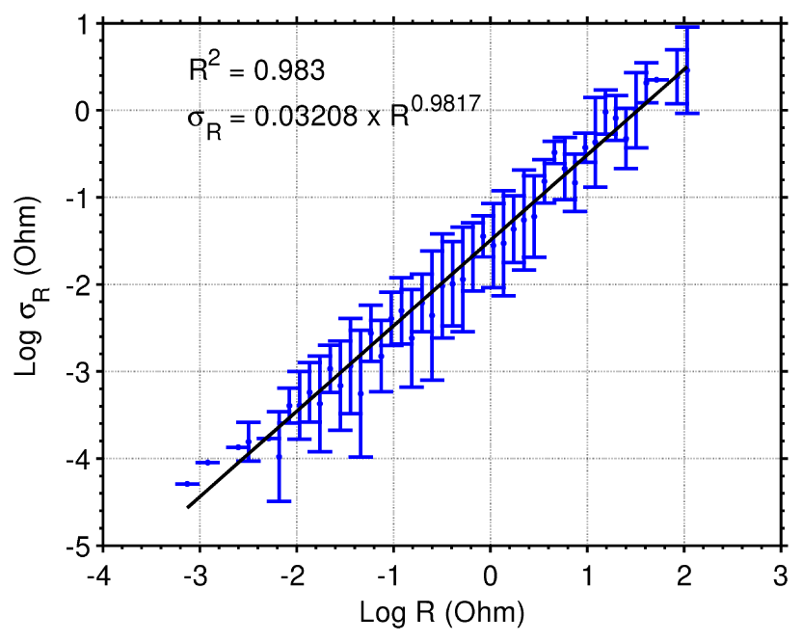

Figure S1. Error model estimated from the reciprocal error analysis. The data are represented by the blue error bars, and the equation that fits the data is represented by the black line.

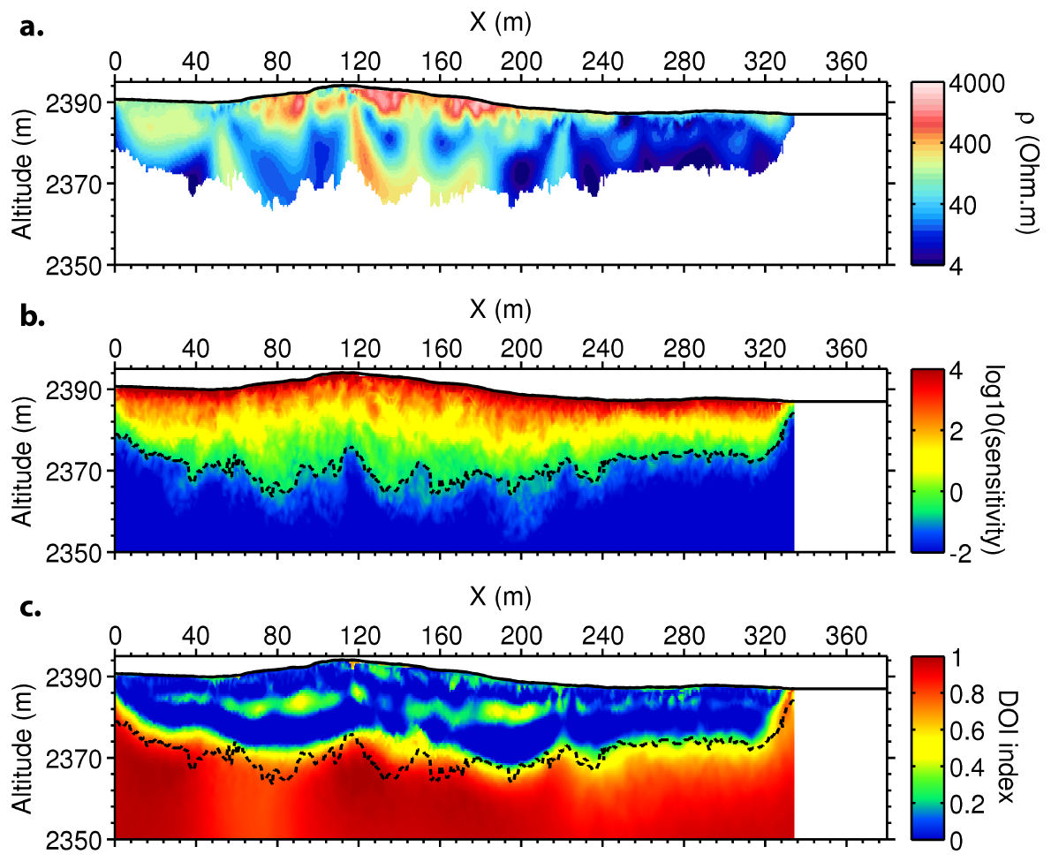

Figure S2. (a) Final electrical resistivity model. (b) Logarithm of the sensitivity. (c) DOI index. The black dashed line corresponds to the depth of investigation estimated from the logarithm of the sensitivity (threshold of -0.75) and the DOI index (threshold of 0.2), using the maximum investigation depth estimated with both criteria at each position along the line.

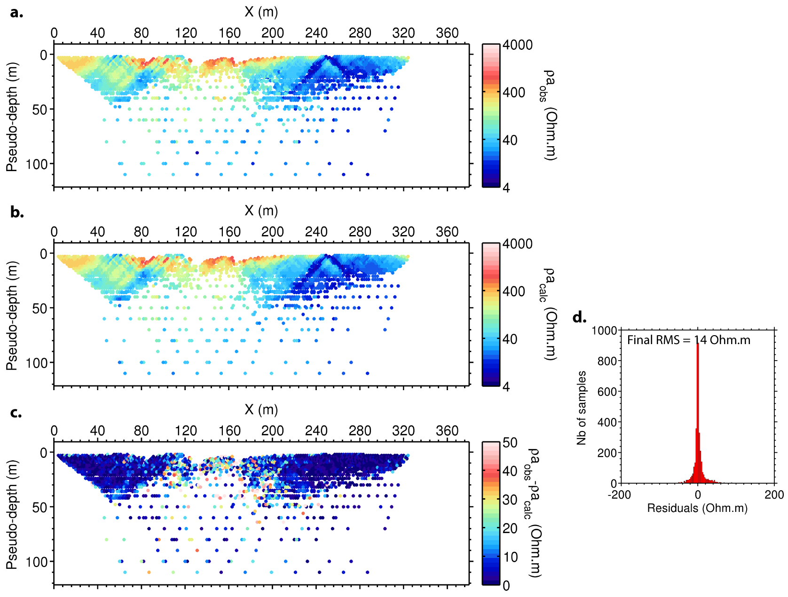

Figure S3. (a) Pseudo-section of observed apparent electrical resistivity. (b) Pseudo-section of calculated apparent electrical resistivity. (c) Pseudo-section of apparent electrical resistivity residuals. (d) Histogram of apparent electrical resistivity residuals.

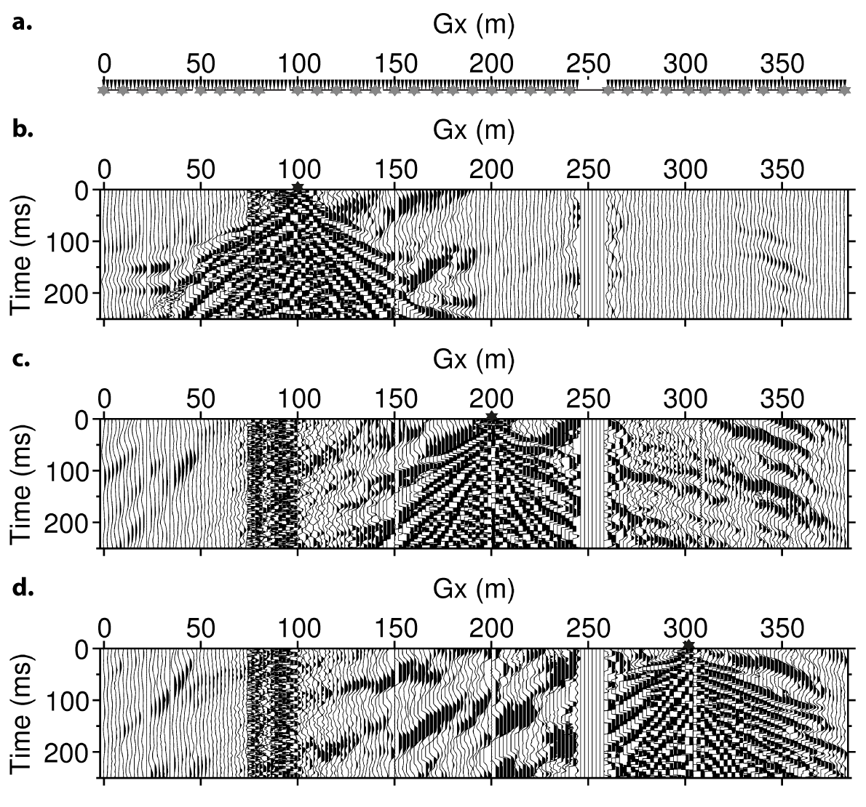

Figure S4. Example of seismograms for shots located at 100 m (a), 200 m (b) and 300 m (c). They all show a high noise level, especially in the area surrounding the “frying pan” (75 to 100 m). Data are missing the “figure-eight” pool due to the impossibility to implement geophones in the pool.

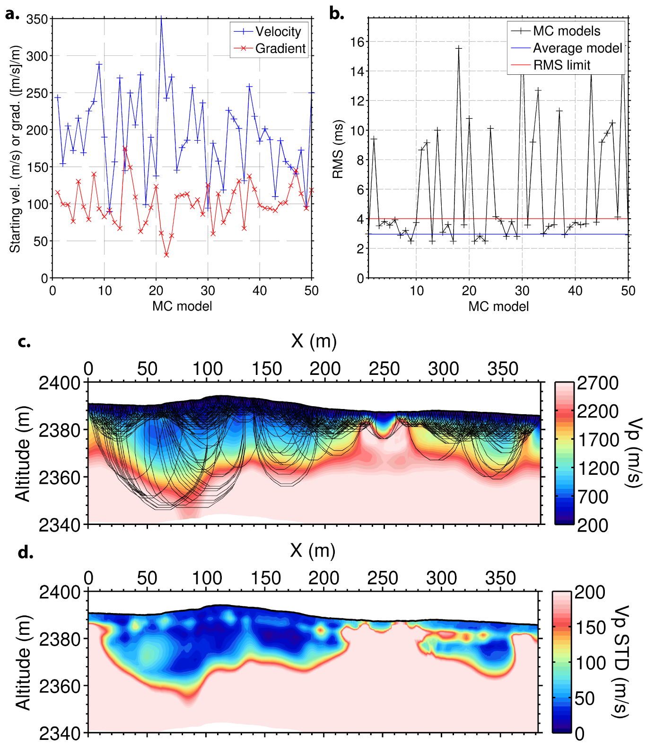

Figure S5. (a) Surface velocity (in blue) and velocity gradient (in red) used for each of the 50 starting models in the Monte Carlo inversion scheme. (b) Final RMS (black cross) for each of the 50 models obtained from the Monte Carlo approach, RMS of the final average model (blue line) built from all models with RMS below the limit (red line). (c) Final average model with ray coverage. (d) Standard deviation (V_{P} STD) of the 50 V_{P} models used to define the depth of investigation (when V_{P} STD reaches 200 m/s).

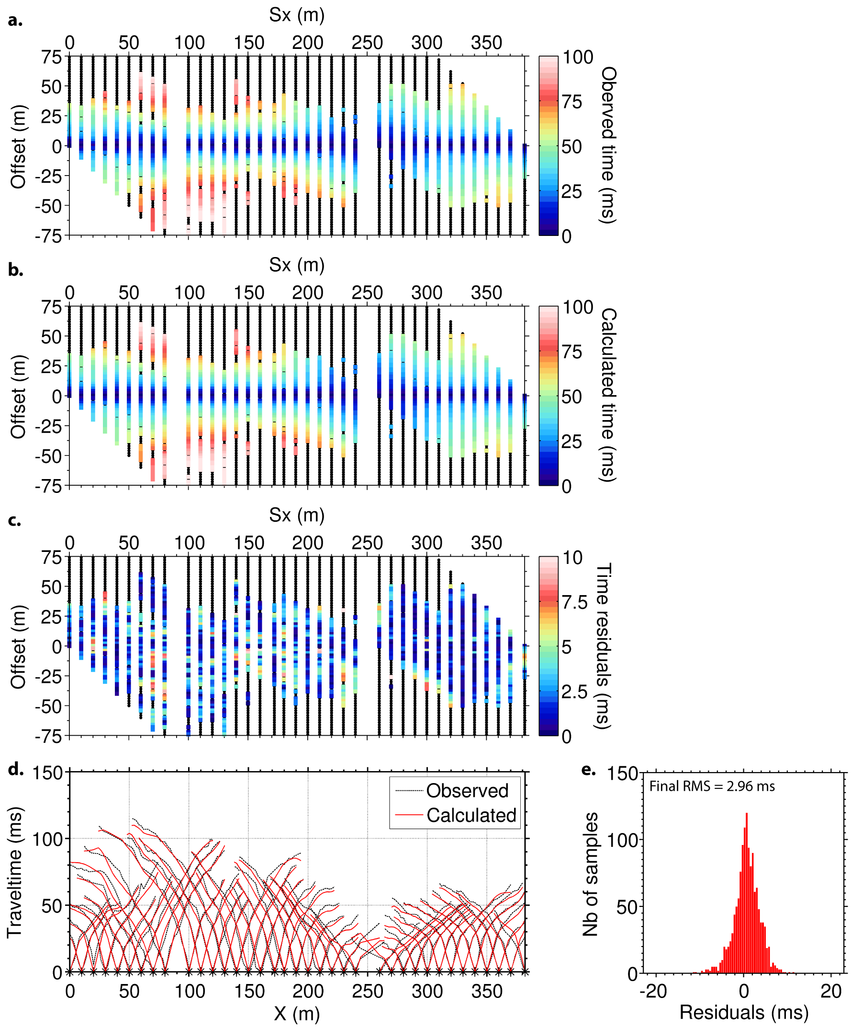

Figure S6. (a) Traveltime observed for each source-receiver pair. (b) Traveltime calculated with the final average model for each pair of source and receiver. (c) Corresponding residuals. (d) Observed (in black) and calculated (in red) traveltimes. (e) Residual histogram and RMS misfit of the final average model.

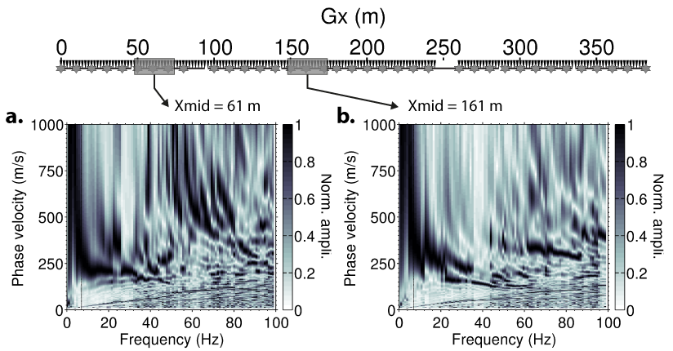

Figure S7. Stacked dispersion images obtained with a 26-m window and direct shots located between 2 and 10 m from the first trace of the window. (a) Image obtained for Xmid = 61 m. (b) Image obtained for Xmid = 161 m.

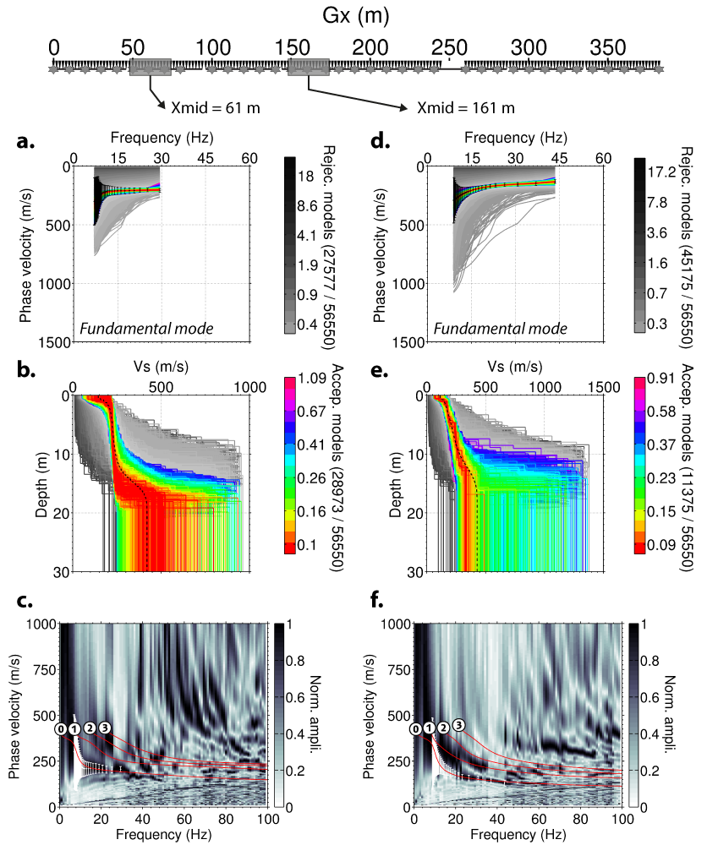

Figure S8. 1D inversion of dispersion data (black error bars) extracted from the stacked dispersion image at Xmid = 61 m (a) and Xmid = 161 m (d) using the NA as implemented by Wathelet et al. [2004]. Resulting models are represented for Xmid = 61 m (b) and Xmid = 161 m (e). Rejected models (i.e., two or more samples of the theoretical dispersion curves calculated from the model does not fit within the error bars) are represented according to their misfit with a greyscale, whereas accepted models (i.e., all or all except one sample of the theoretical dispersion curves calculated from the model fit within the error bars) are represented with a color scale. Average parameters of all accepted models were used to build a misfit-weighted velocity structure associated with the center of the extraction window (black dashed lines in b and e). Dispersion curves are then computed at each Xmid position using the final average V_{S} model and a 1D V_{P} model extracted from the P-wave refraction tomography section. Theoretical dispersion curves are superimposed to the dispersion image for Xmid = 61 m (c) and Xmid = 161 m (f).
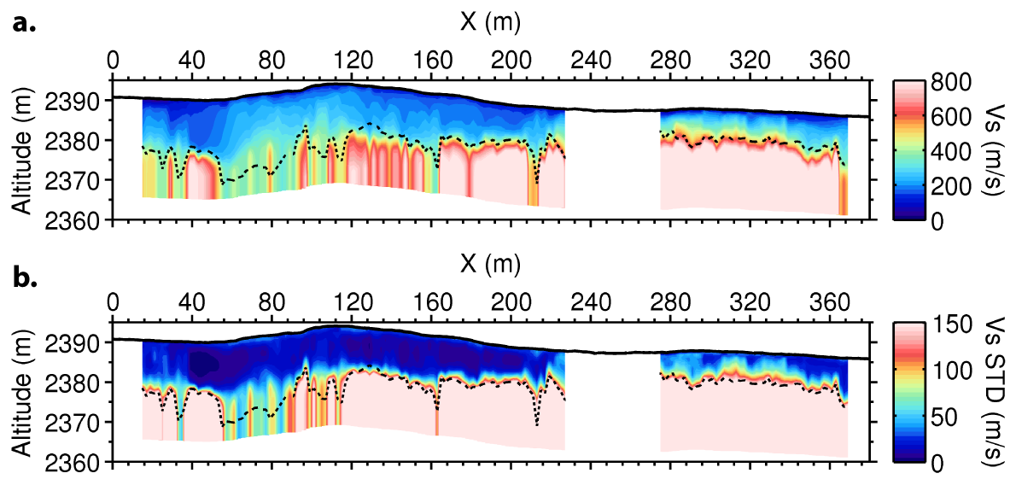

Figure S9. (a) Final 2D pseudo-section of V_{S} built from all final average 1D V_{S} models. (b) Standard deviation of V_{S} along the line. The black dashed line corresponds to the depth of investigation estimated with a V_{S} standard deviation threshold of 150 m/s.

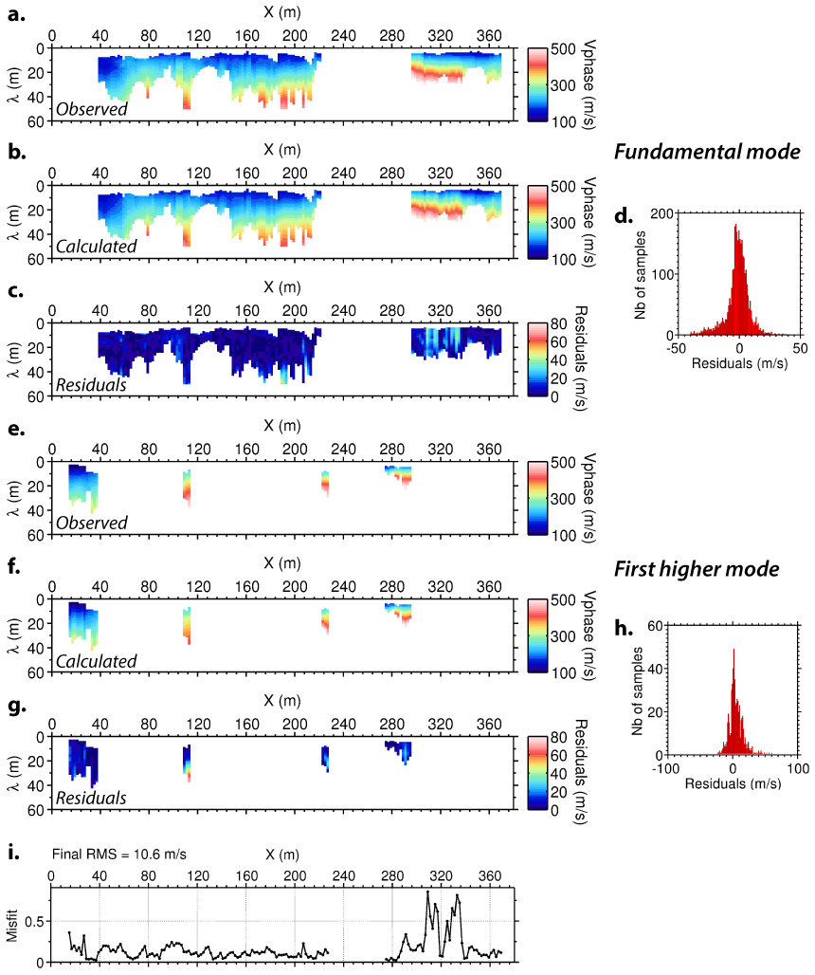

Figure S10. (a) Pseudo-section of observed phase velocity for the fundamental mode. (b) Pseudo-section of calculated phase velocity for the fundamental mode. (c) Pseudo-section of residuals for the fundamental mode. (d) Histogram of residuals for the fundamental mode. (e) Pseudo-section of observed phase velocity for the first higher mode. (f) Pseudo-section of calculated phase velocity for the first higher mode. (g) Pseudo-section of residuals for the first higher mode. (h) Histogram of residuals for the first higher mode. (i) Misfit values calculated for each 1D inversion along the line.

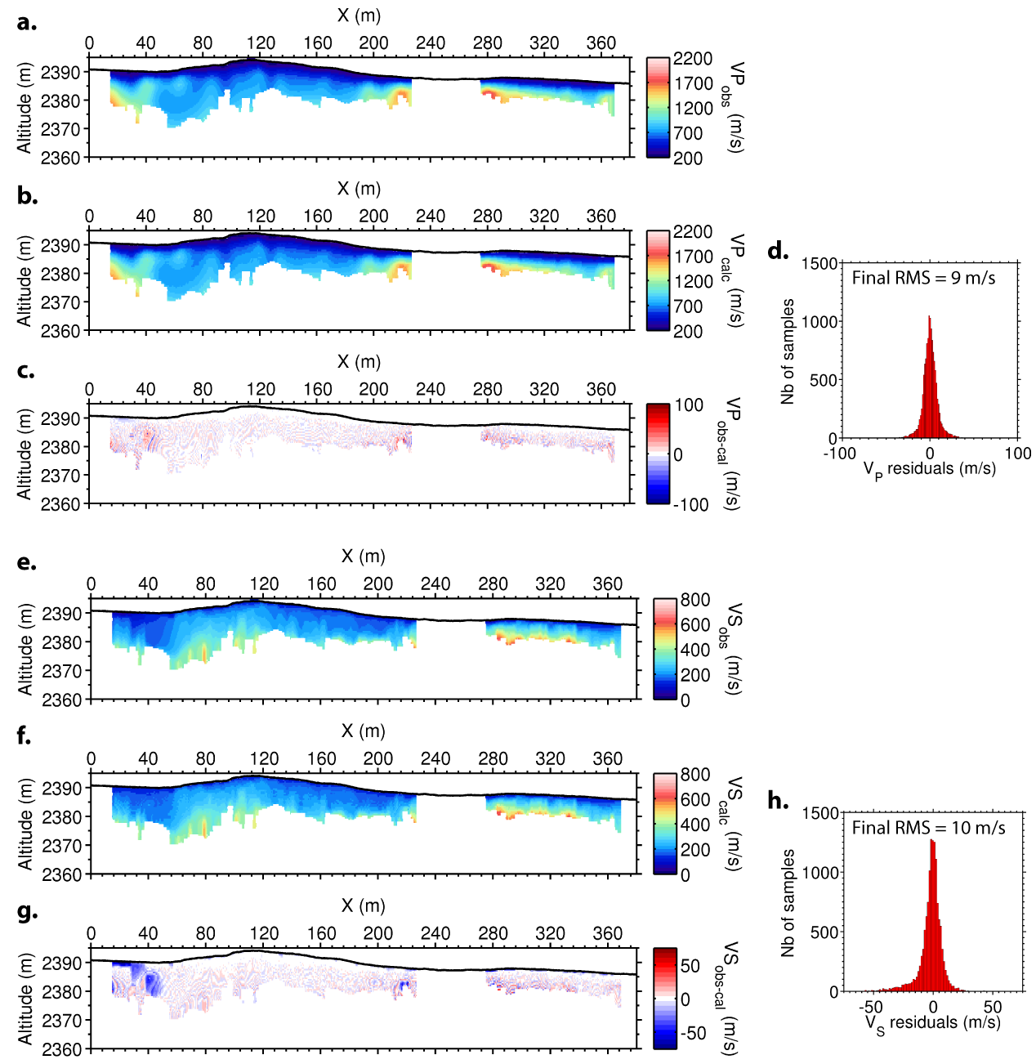

Figure S11. (a) Observed V_{P} obtained from P-wave tomography. (b) Calculated V_{P} with the rock physics model. (c) Corresponding V_{P} residuals. (d) Histogram of V_{P} residuals. (e) Observed V_{S} obtained from surface-wave dispersion inversion and profiling. (f) Calculated V_{S} with the rock physics model. (g) Corresponding V_{S} residuals. (h) Histogram of V_{S} residuals.

Mineral constituent | Bulk modulus (GPa) | Shear modulus (GPa) | Density (kg/m³) | Proportion of the solid frame
Quartz | 37 | 44 | 2650 | 0.4
Feldspar | 37.5 | 15 | 2620 | 0.1
Clay | 1.5 | 1.4 | 1580 | 0.5
Water | 2.2 | - | 1000 | -
Gas | 1.01e-4 | - | 0.92 | -

Table S1. Elastic parameters used in the rock physics model [Mavko et al., 2003].

